RCBO

NB1L-63 Residual Current Operated Circuit Breaker
with over-current protection(Magnetic)

1. General
1.1 Certificates: CB, CE, FIMKO, SEMKO, PCT, UKREST;
1.2 Electric ratings:up to 63A, 230V/1P+N, 2P, 400V/3P, 3P+N, 4P, AC50/60Hz;
1.3 Tripping characteristics: B, C, D;
1.4 Icn: 1~40A: 6000A/10000A
50~63A: 6000A
1.5 Rated residual current operated making & breaking capacity
I m: 500 A;
1.6 Rated residual non-operated current I no: 0.5I n;
1.7 Rated insulation voltage Ui : 500 V;
1.8 Rated impulse withstand voltage Uimp: 6000 V;

1.9 Life (operations):
a. Electrical life: 2000, COS =0.85~0.9
b. Mechanical life: 2000
c. Operating frequency: 240/h(In 25A); 120/h(In 25A);
1.10 Standard: IEC/EN 61009-1.

2. Type Designation
N B1L

Frame level rated current Derivative code (electro-magnetic residual current operated circuit breaker) Design sequence number
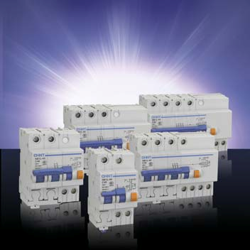

Miniature circuit breaker
Company code

3. Technical Data
3.1 Technical parameters
NB1L-63, 1P+N
2 |  | N

N  1 T | In  (A) | I n  (mA) | CTN | Order Code
 |  |  |  | Curve B | Curve C | Curve D
N  1 T | 1 | 30 | 48 | 142001 | 142166 | 142331
N  1 T | 1 | 100 | 48 | 142002 | 142167 | 142332
N  1 T | 1 | 300 | 48 | 142003 | 142168 | 142333
N  1 T | 2 | 30 | 48 | 142004 | 142169 | 142334
N  1 T | 2 | 100 | 48 | 142005 | 142170 | 142335
N  1 T | 2 | 300 | 48 | 142006 | 142171 | 142336
N  1 T | 3 | 30 | 48 | 142007 | 142172 | 142337
N  1 T | 3 | 100 | 48 | 142008 | 142173 | 142338
N  1 T | 3 | 300 | 48 | 142009 | 142174 | 142339
N  1 T | 4 | 30 | 48 | 142010 | 142175 | 142340
N  1 T | 4 | 100 | 48 | 142011 | 142176 | 142341
N  1 T | 4 | 300 | 48 | 142012 | 142177 | 142342
N  1 T | 6 | 30 | 48 | 142013 | 142178 | 142343
N  1 T | 6 | 100 | 48 | 142014 | 142179 | 142344
N  1 T | 6 | 300 | 48 | 142015 | 142180 | 142345

.31. .32.

.38.

